Use Case:
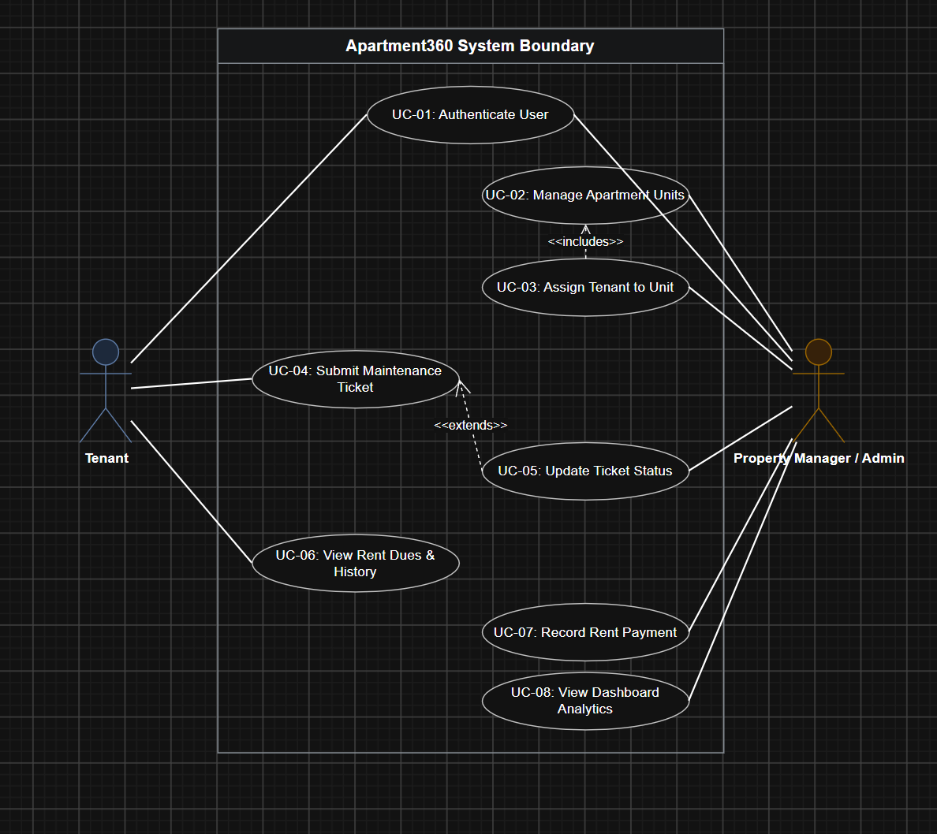
Use Case Specifications & Diagram
Project Name: Apartment360 – Apartment Housing Management System
Document Version: 1.0
1. Use Case Diagram
Code snippet
graph LR
subgraph Apartment360 System Boundary
UC1([UC-01: Authenticate User])
UC2([UC-02: Manage Apartment Units])
UC3([UC-03: Assign Tenant to Unit])
UC4([UC-04: Submit Maintenance Ticket])
UC5([UC-05: Update Ticket Status])
UC6([UC-06: View Rent Dues & History])
UC7([UC-07: Record Rent Payment])
UC8([UC-08: View System Dashboard Analytics])
end

Tenant((Tenant))
Admin((Property Manager / Admin))

Tenant --> UC1
Tenant --> UC4
Tenant --> UC6

Admin --> UC1
Admin --> UC2
Admin --> UC3
Admin --> UC5
Admin --> UC7
Admin --> UC8

UC3 ..> UC2 : <<includes>>
UC5 ..> UC4 : <<extends>>
2. Actor Glossary
Actor Name | Type | Description
Tenant | Primary | A registered resident assigned to an apartment unit who submits maintenance issues and checks rent balances.
Property Manager / Admin | Primary | System administrator responsible for managing property units, tenant assignments, ticket lifecycle, and financial tracking.
Database System | Secondary | Automated MongoDB persistence layer enforcing schema rules, unique keys, and relationship integrity.
3. High-Detail Use Case Specifications
Instructors for Principles of Software Engineering evaluate Use Cases based on formal flow details (preconditions, main success scenarios, and alternative flows). Below are full specifications for the system's two core workflows.
Use Case Specification: UC-04 (Submit Maintenance Ticket)
Field | Description
Use Case ID | UC-04
Use Case Name | Submit Maintenance Ticket
Primary Actor | Tenant
Mapped Requirements | FR-06.1, FR-06.2, NFR-01, NFR-12
Description | Allows an authenticated tenant to log a maintenance request (e.g., plumbing, electrical issue) to alert management.
Preconditions | 1. Tenant must be logged into their active account.  2. Tenant must be currently assigned to an active apartment unit.
Postconditions | A new ticket document is saved in MongoDB with status Pending, linked to the tenant's unitId and tenantId.
Flow of Events
[Tenant] [React Frontend] [Express/MongoDB Backend]
│ │ │
│─── 1. Clicks "New Ticket" ──────>│ │
│ │─── 2. Displays Ticket Form ─────────────>│
│─── 3. Enters details & submits ─>│ │
│ │─── 4. POST /api/tickets (JWT Header) ───>│
│ │ │─── 5. Validates payload
│ │ │─── 6. Saves document (Pending)
│ │<── 7. HTTP 201 Created (JSON Payload) ───│
│<── 8. Renders Success Alert ─────│ │
Main Success Scenario (MSS)
- Tenant navigates to the Maintenance Request page on the portal.
- The system renders the ticket creation form containing Issue Title, Category, Priority Level (Low, Medium, High), and Description.
- Tenant enters the details and clicks Submit Ticket.
- The frontend performs input validation to verify fields are non-empty.
- The frontend transmits a POST /api/tickets payload to the backend server containing the user's JWT token.
- The server validates the user's token, attaches tenantId and unitId, assigns status = Pending, and saves the entry to MongoDB.
- The server returns HTTP status 201 Created with the new ticket payload.
- The frontend clears the form and displays a success notification with the generated Ticket ID.
Alternative & Exception Flows
- A1: Incomplete Form Fields
  - At Step 4: If mandatory fields are blank, the client halts form submission and displays red validation error text under affected fields.
- E1: Expired Auth Session
  - At Step 6: If the JWT token is expired, the server responds with HTTP status 401 Unauthorized.
  - Action: The frontend clears cached session storage and redirects the user to the Login Page with message "Session expired. Please log in again."
Use Case Specification: UC-03 (Assign Tenant to Unit)
Field | Description
Use Case ID | UC-03
Use Case Name | Assign Tenant to Apartment Unit
Primary Actor | Property Manager / Admin
Mapped Requirements | FR-04.1, FR-05.1, FR-05.2
Description | Allows an administrator to link an unassigned tenant user account to an available vacant unit, updating lease and unit statuses.
Preconditions | 1. Admin must be authenticated with role = Admin.  2. Target apartment unit must have status = Vacant.  3. Target tenant must not hold another active unit assignment.
Postconditions | 1. Target unit status changes from Vacant to Occupied.  2. Tenant document's unitId field updates to link to the unit.
Main Success Scenario (MSS)
- Admin navigates to the Unit Management Dashboard.
- Admin locates a unit marked as Vacant and clicks Assign Tenant.
- System displays a modal with a dropdown list showing registered tenants who currently lack a unit assignment.
- Admin selects a tenant from the list and submits the assignment form.
- Frontend sends a PATCH /api/units/:id/assign request with the selected tenantId.
- Backend updates the unit record (status = "Occupied", tenantId = selectedTenantId) and updates the user record in an atomic transaction.
- Server responds with HTTP status 200 OK.
- Frontend refreshes the unit list table, reflecting the updated occupant name and Occupied status badge.
Alternative & Exception Flows
- A1: Unit Already Occupied
  - At Step 5: If another administrator assigned a tenant to the unit concurrently, the backend returns HTTP status 409 Conflict.
  - Action: Frontend displays error banner: "Unit is no longer vacant. Page refreshed." and updates table data.
4. Use Case to Requirement Traceability Matrix
Use Case ID | Use Case Name | Primary Actor | Mapped Requirement IDs
UC-01 | Authenticate User | Tenant, Admin | FR-01.1, FR-01.2, FR-02.1, FR-02.2
UC-02 | Manage Apartment Units | Admin | FR-03.1, FR-03.2, FR-04.2
UC-03 | Assign Tenant to Unit | Admin | FR-04.1, FR-05.1, FR-05.2
UC-04 | Submit Maintenance Ticket | Tenant | FR-06.1, FR-06.2, FR-08.1
UC-05 | Update Ticket Status | Admin | FR-07.1, FR-07.2
UC-06 | View Rent Dues & History | Tenant | FR-09.1
UC-07 | Record Rent Payment | Admin | FR-10.1, FR-10.2
UC-08 | View Dashboard Analytics | Admin | FR-11.1

